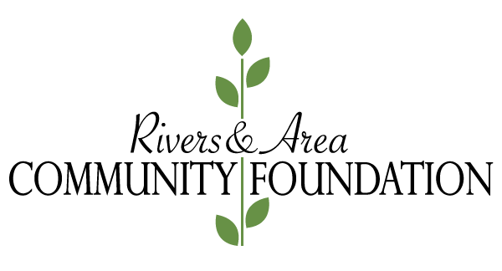 **Grant Application Form**

|  |  |  |  |
| --- | --- | --- | --- |
| **Organization Name:** |  | | |
| **Primary Contact:** |  | | |
| **Position:** |  | | |
| **Address:** |  | | |
| **Postal Code:** |  | **Phone #:** |  |
| **Charitable # or Incorporated Business #** |  | | |
| **Date of Incorporation:** |  | **Website:** |  |
| **Number of Employees:** | |  |  |  |  |  |  | | --- | --- | --- | --- | --- | --- | | **Full Time:** |  | **Part Time:** |  | **Volunteers:** |  | | | |

**PREVIOUS GRANTS**

Please list previous grants received from Rivers and Area Community Foundation:

|  |  |  |
| --- | --- | --- |
| Date | Purpose | Amount Received |
|  |  |  |
|  |  |  |
|  |  |  |

Were Final Grant Reports filed? ( ) Yes ( ) No

**ORGANIZATION INFORMATION**

1.What is the purpose of the organization?

|  |
| --- |
|  |

2. What services are provided? Include your target population, geographic area served, and number of people served.

|  |
| --- |
|  |

**GRANT REQUEST**

|  |  |  |  |
| --- | --- | --- | --- |
| **Amount Requested:** |  | **Total Cost of Project:** |  |

|  |  |  |  |
| --- | --- | --- | --- |
| **Project  Start Date:** |  | **Completion Date:** |  |

1. **Please provide the project description on a separate word document and attach it to the application.**
2. **Source(s) of Funding:**

Please identify other sources of funding and dollar amounts for this project:

|  |  |  |
| --- | --- | --- |
| **Name** | **Amount** | **Pending or Confirmed?** |
|  |  | ( ) Pending ( ) Confirmed |
|  |  | ( ) Pending ( ) Confirmed |
|  |  | ( ) Pending ( ) Confirmed |

1. **Partial Funding**

**Would your organization be able to continue the project if you were only to receive partial funding in support of your request?** ( ) Yes ( ) No

**If yes, please provide more detail:**

|  |
| --- |
|  |

1. **How will this project be evaluated?**

|  |
| --- |
|  |

1. **Once your project is completed, how will your organization recognize RACF and other funding partners?**

|  |
| --- |
|  |

**COMMUNITY REFERENCES**

Please provide the name, telephone number and contact person of two (2) organizations who may be contacted by the Rivers and Area Community Foundation in support of your organization’s application for funding.

|  |  |  |  |
| --- | --- | --- | --- |
| **Name:** |  | **Contact Person:** |  |
| **Email:** |  | **Phone #:** |  |

|  |  |  |  |
| --- | --- | --- | --- |
| **Name:** |  | **Contact Person:** |  |
| **Email:** |  | **Phone #:** |  |

**ATTACHMENTS TO BE INCLUDED**

Please check off items to ensure that you have included all required documentation to complete your grant application:

( ) The most current audited or reviewed financial statement

( ) The total revenue and expense budget for the current year

( ) The Budget for the proposed project

( ) A list of the current board members and their contact information

**AUTHORIZATION**

This application must be signed by an **officer of the organization’s Board of Directors (this includes Chair/President, Vice Chair/Vice President, Treasurer, Executive Director or General Manager of the organization).** By signing this application, the applicant agrees to the grant terms and conditions and gives the RACF permission to publish photographs, grant recipient stories and grant information upon the approval of the grant.

(Grant Applications, which are not approved will remain confidential)

|  |  |  |  |
| --- | --- | --- | --- |
| **Name & Title (Print)** | **Signature** | **Phone #** | **Date** |
|  |  |  |  |

**SUBMITTING YOUR APPLICATION**

You have two options of submitting the application:

1. Download the document and email the completed application and all the attachments to info@riversareacommunityfoundation.org
2. Mail the completed application with all attachments to Rivers and Area   
   Community Foundation Box 714 Rivers, MB. It must be postmarked no later than September 30th.
   * Disclaimer: RACF is not responsible for electronic applications not received.
   * Completed application and required supporting documentation must be **received** no later than 5 p.m. on September 30th.
   * **For more information contact any of the Board of Directors (see website) or by emailing the RACF at info@riversareacommunityfoundation.org**
   * Any personal information requested on this application will only be used to assist with the assessment of your grant application.